Temperature change statistics1961-2019

Global, regional and country trends

# Climate Change

Climate change is a critical issue that the world is currently facing, as indicated by the historical temperature changes. In this project, I aim to explore the connection between industrial activities and the greenhouse effect and their impact on temperature increases. Before conducting my investigation, the aim of this part is to briefly highlight the key aspects of temperature change data for different regions. Through analyzing temperature change data, I have determined the problems, their causes, and effects in a succinct manner.

## What is Climate Change?

*Climate change describes a change in the average conditions — such as temperature and rainfall — in a region over a long period of time. NASA scientists have observed Earth’s surface is warming, and many of the warmest years on record have happened in the past 20 years.*

## Weather vs Climate

***Weather****describes the conditions outside right now in a specific place. For example, if you see that it’s raining outside right now, that’s a way to describe today’s weather. Rain, snow, wind, hurricanes, tornadoes — these are all weather events.*

***Climate****, on the other hand, is more than just one or two rainy days. Climate describes the weather conditions that are expected in a region at a particular time of year.*

***Note:*** Is it usually rainy or usually dry? Is it typically hot or typically cold? A region’s climate is determined by observing its weather over a period of many years—**generally 30 years or more.**

# Causes of Climate Change

According to **NASA**, the greenhouse effect is caused by a number of gases, including water vapor, carbon dioxide (CO2), methane, nitrous oxide, and chlorofluorocarbons (CFCs). Over the past century, human activities have led to an increase in the levels of these natural greenhouse gases.

# Effects of Climate Change

* Rising sea levels
* Shrinking mountain glaciers
* Ice melting at a faster rate than usual in Greenland, Antarctica and the Arctic
* Changes in flower and plant blooming times.
* Extreme weather
* Dirty air
* Health risks
* Warmer, more acidic oceans
* Risked ecosystem.

# Data Selection

The National Aeronautics and Space Administration Goddard Institute for Space Studies (NASA-GISS) makes available to the public data on global surface temperature change. The data set provided by the FAOSTAT Temperature Change domain includes additional information, such as area names. As the focus of this project is on country names, I have chosen to use the FAO's data set.

# Dataset information

**Data Type:** Climate Change – Temperature Change

**Time Period:** 1961–2019

**Periodicity:** Monthly, Seasonal, Annual

**Geographical Coverage:** World

The first seven columns include information about temperature changes, the other columns show temperature change numbers between 1961 and 2019. And, all years have some missing values. When I examine the first seven columns detail;

1. **Area Code:** The numerical code of area column, type of area code is an integer.
2. **Area:** Countries and Territories (In 2019: 190 countries and 37 other territorial entities.), type of area is an object.
3. **Months Code:** The numerical code of months column, type of months code is an integer.
4. **Months:** Months, Seasons, Meteorological year, type of months is an object.
   * **Months**: 'January', 'February', 'March', 'April', 'May', 'June', 'July’, ‘August', 'September', 'October', 'November', 'December'
   * **Seasons**: 'Dec\x96Jan\x96Feb', 'Mar\x96Apr\x96May', 'Jun\x96Jul\x96Aug','Sep\x96Oct\x96Nov'
   * **Year**: 'Meteorological year'
5. **Element Code:** The numerical code of element column, type of element code is an integer.
6. **Element:** 'Temperature change', 'Standard Deviation', type of element is an object.
7. **Unit:** Celsius degrees °C, type of unit is an object.

# Introduction

Rising greenhouse gas concentrations are causing an increase in land surface air temperature, which poses a threat to the livelihoods of farmers and communities globally. The FAOSTAT Temperature Change statistics provide country-specific information on observed warming trends on land, which can be used to identify risks and develop responses to safeguard the agriculture, forestry, and fisheries sectors.

The FAOSTAT Temperature Change statistics are available for the period between 1961 and 2021 for 197 countries and 41 territories. They are developed in partnership with the NASA Goddard Institute for Space Studies (NASA-GISS) and are based on regularly updated temperature readings from an extensive network of meteorological stations worldwide. Temperature change data in FAOSTAT is presented as monthly, annual, and seasonal means. The data provides information on mean temperature changes, characterized as statistically significant 'warmer,' 'much warmer,' or 'colder' anomalies with respect to the climatology of the period 1961-1980, which is considered as the climatic normal.

# Examining the Guiding Queries/Questions

**1**. Which are the top ten countries that have experienced the greatest temperature changes in the last decade?

## Why?

It is a known fact that the rate of global warming has increased in the last decade. My goal is to identify which countries have been affected the most by this issue.

## Explanation

I intend to present the names of countries and their average temperature change values for the past decade. I have selected the last ten years as the time frame and grouped the values by country. I have then sorted them in descending order and limited the output to the top ten values.

## Results

The top ten list includes countries/region in Europe as well as the European Union, which is affected the most by climate change, along with its neighbor, Russia. This is not surprising as all the countries on the list are industrialized countries, with the exception of 'Svalbard and Jan Mayen Islands.' This region is at the top of the list, located near Europe and Russia and is an Arctic area, thus its natural life is at risk due to climate change. This graph showing the temperature change for top 10 countries from 2010 to 2019. The highest temperature change occurred in Svalbard and Jan Mayen Islands and it was 3.26°C. The highest 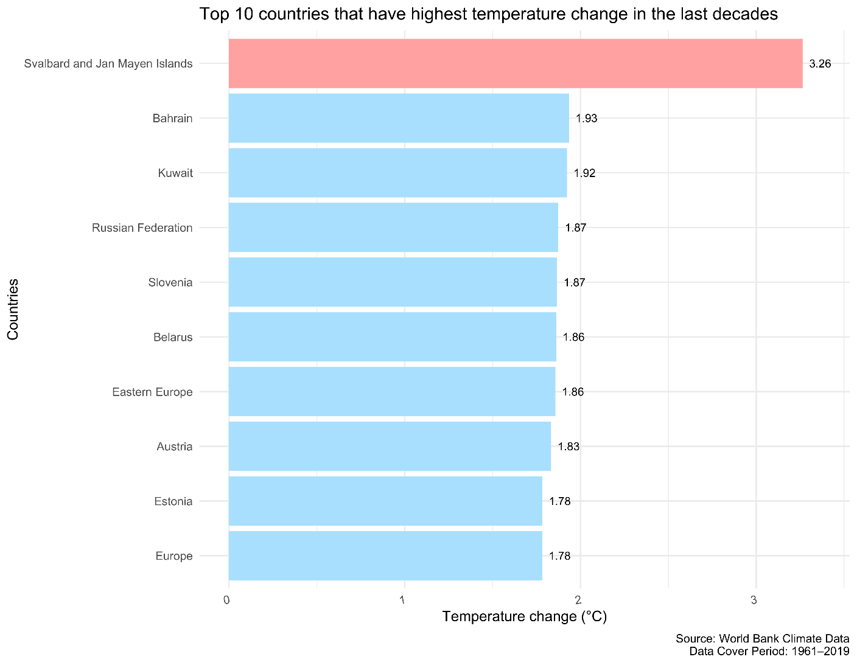temperature change in Svalbard and Jan Mayen Islands almost 2 times higher than other countries.

**2.** What are the names of the top ten countries that have been least affected by temperature change in the last ten years?

**Why?**

I wanted to identify the countries with the lowest temperature change in the last decade as the inverse version of the previous inquiry.

**Explanation**

I intended to present the names of countries and their average temperature change values for the past decade. I selected the last ten years as the time frame and grouped the values by country.

**Results**

I found it surprising that India appears on the list. Despite being a developing country, it has a significant number of industrial activities. However, this list suggests that these activities have had little impact on rising temperatures. As I had anticipated, there are no developed countries on the list.

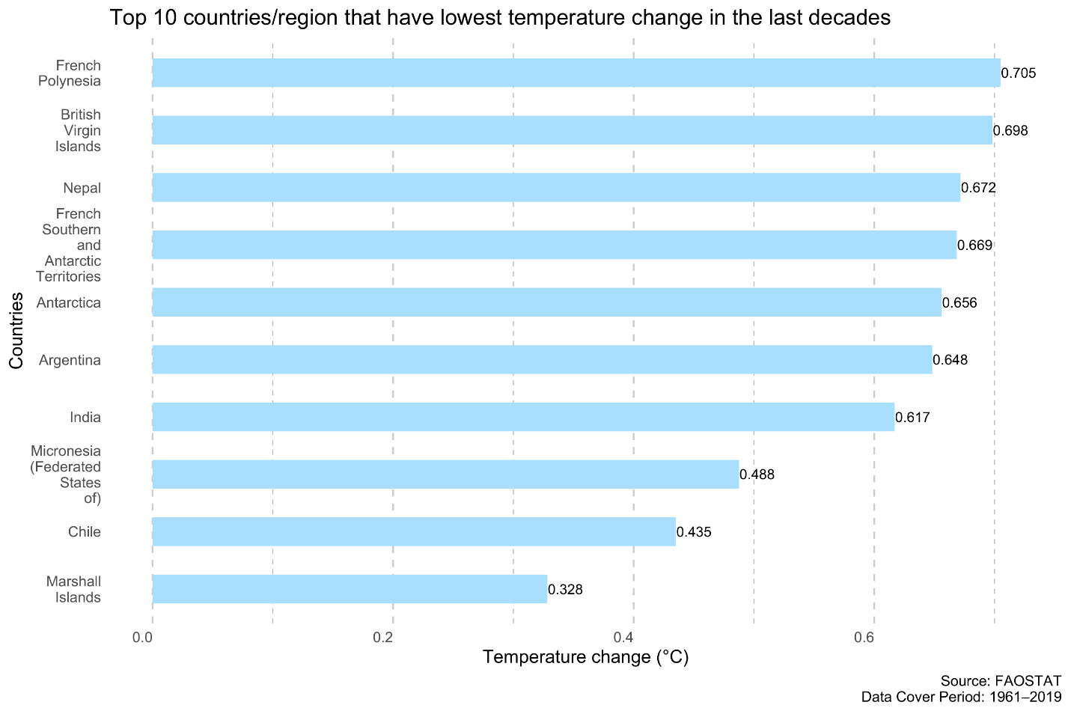

**3.** Are there any remarkable temperature change trends over the years for the world, **Annex I countries, and non-Annex I countries**? If so, can we divide these into distinct periods?

**Why?**

In this inquiry, I aim to investigate the relationship between industrialization and temperature change over time. 'Annex I countries' refer to industrialized countries, and 'Non-Annex I countries' are mostly developing countries that are vulnerable to the negative impacts of climate change. For this reason, I will compare the temperature change data of 'Annex I countries,' 'Non-Annex I countries' and 'World' on a yearly basis to examine the effects of industrialization.

**Explanation**

I filtered Annex I countries and Non-Annex countries and them in two dataset where both dataset contains two column year and temperature change. The temperature average of the world also used in this graph.

**Results**

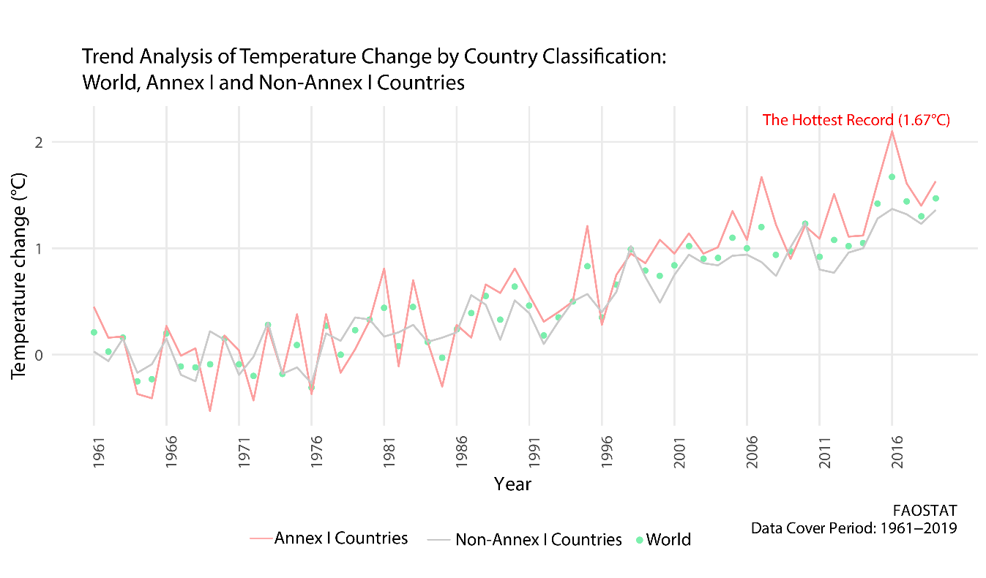While analyzing the graph and comparing the results, it is evident that 'Annex I countries' have a relatively steady trend, whereas 'Non-Annex I countries' show more fluctuations, and also, have several high points. This indicates that global warming has been accelerating more rapidly for industrialized countries. Conversely, as anticipated, the values for the world fall between those of the other two categories. In summary, we can roughly divide the data into ten-year periods based on the values of 'Annex I countries' as each decade has a higher peak value than the previous one.

**4.** Is there any significant difference between **seasons**?

**Why?**

This question, similar to the previous one, aims to investigate the seasonal impact of climate change in addition to the yearly trend.

**Explanation**

I created four separate tables for each season, containing temperature change values. Before combining them into one table, I labeled each temperature change value with its corresponding season ('Winter,' 'Spring', 'Summer’, ‘Fall').

**Results**

While analyzing the graph and comparing the results, it is evident that Summer has a relatively steady trend, whereas Winter has more fluctuations, and also, has several high points. This illustrates that global warming's effects are more pronounced in the winter season. While spring also has similar fluctuations to winter, fall has a similar trend to summer. Furthermore, it can also be observed that the world had the warmest (2.17°C) winter in 2016, the warmest spring was 2°C in 2016, the warmest summer was 1.36°C in 2016 and the warmest fall was 1.47°C in 2015. The seasonal temperature change showed the upward increasing change over the years for every season

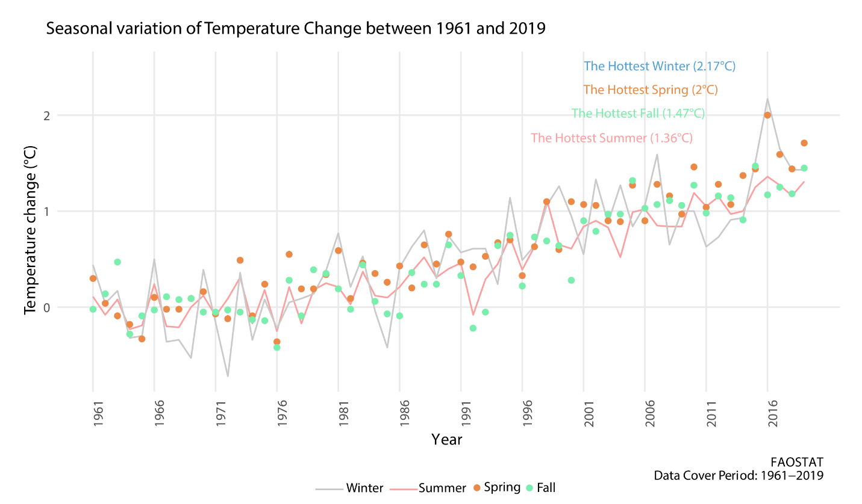

**5.** Is there any significant changes of temperatures over the year?

**Why?**

This question, similar to the previous one, aims to investigate the significant changes of temperatures over the year using the **heatmap**

**Explanation**

I created a table where columns are containing month, temperature change values, and year.

**Results**

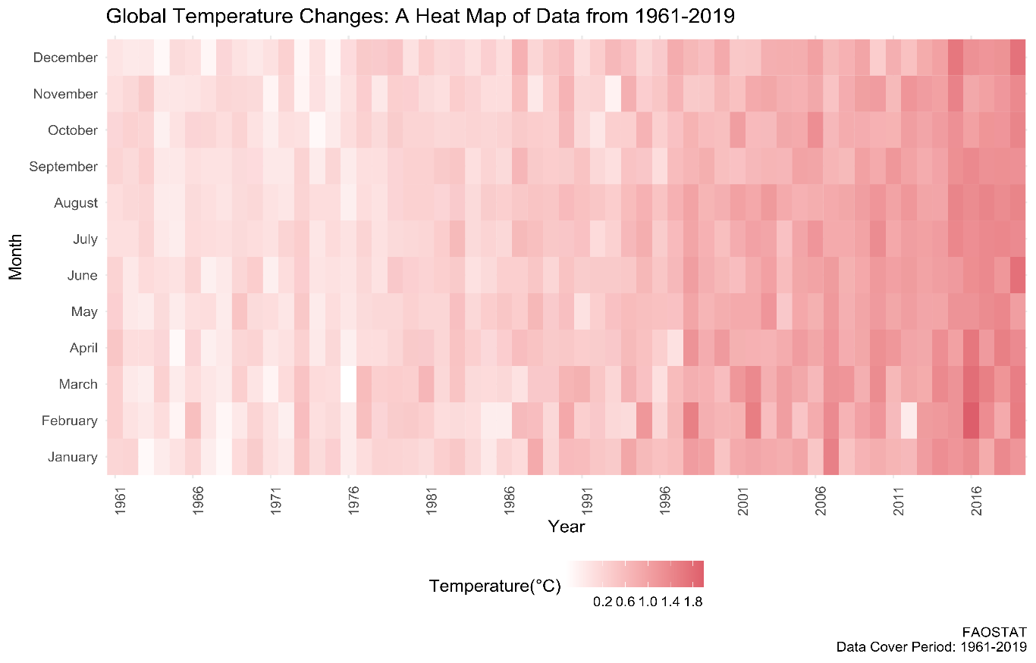A heat map is a graphical representation of data where individual values are represented as colors. In this case, the heat map would show the temperature changes increasing from 1961 to 2019. The colors used in the map would represent the magnitude of the temperature change, with darker colors indicating a higher temperature change and lighter colors indicating a lower temperature change. The heat map would allow for a quick visual representation of the temperature changes over time, making it easy to identify patterns, trends, and areas where temperature changes are particularly high or low. This can be useful for identifying regions that are most affected by climate change, as well as for understanding how temperature changes have evolved over time. Additionally, it could be used to compare temperature changes from different regions of the world and also to show the difference between different periods of time. Average temperature change was **+1.4°C in 2016** and **1961 it was +0.18°C**. The difference in **+1.22°C which indicates the positive changes of temperature.**

**6.** Is there any significant difference of temperature changes on **continents**?

**Why?**

The aims to investigate the temperature changes on continents to see the difference between all continents.

**Explanation**

I created seven separate tables for each continent, containing temperature change values and year.

**Results**

In 2019, land in the northern hemisphere saw larger warming than in the southern hemisphere. Europe registered the largest mean annual temperature change (2.3 ⁰C), followed by Northern America (2.27 ⁰C) that in FAOSTAT aggregates includes the Russian Federation, then Africa (1.54 ⁰C) and Africa (1.46 ⁰C). Warming in South America and Oceania was 1.44 ⁰C and 1.40 ⁰C, respectively. All regions recorded an upward trend in the past decades.

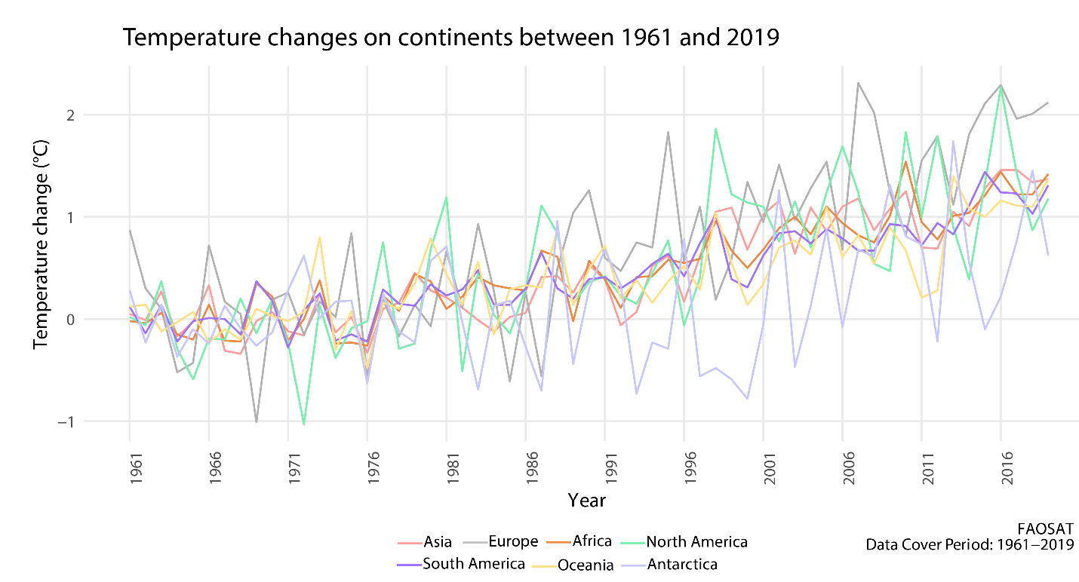

**6.** What are the trends in mean annual temperature changes measured over two phases (1961 – 2000 & 2001-2019)?

**Why?**

Mean annual temperature changes measured over the land, global and regional trends.

**Explanation**

For this investigation purposes I created two separate table. One is for the 1961 to 2000 and other is for 2001 to 2019. Then merge these two datasets.

**Results**

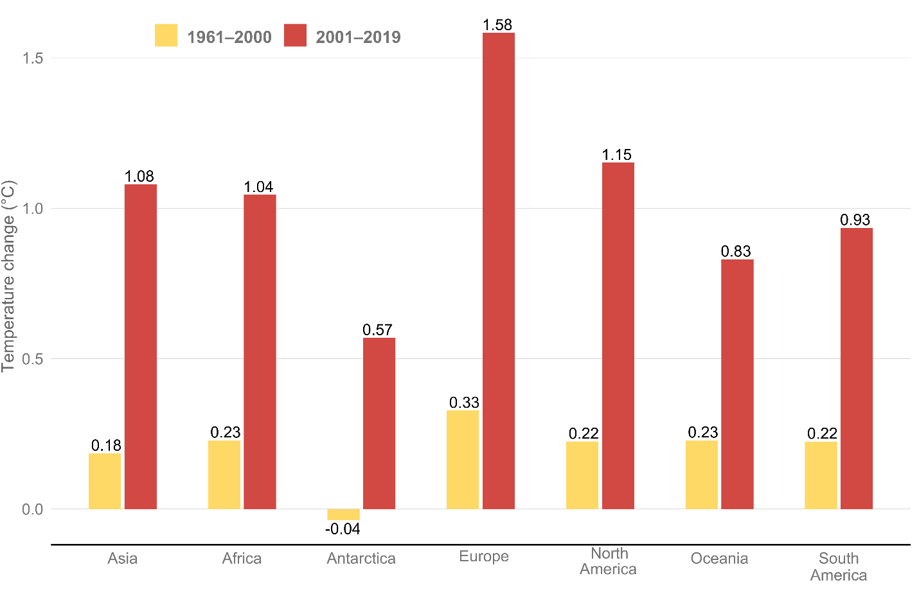In all regions, the decadal mean warming was greater in the last decades (2001-2019) compared to the previous one (1961–2000). The largest absolute increase was recorded in Europe, where the more recent decade was about 1.25⁰C warmer than previous one. The smallest absolute increase was in Antarctica, where the 2001-2019 decades were 0.61 ⁰C warmer than 1961–2000. Nonetheless, the comparison of regional trends (and country trends, relevant to the next section) may be biased due to uneven coverage and time evolution of meteorological stations in the different regions.

**Conclusion**

In the study, the global surface temperature was analyzed from 1961 to 2019. The findings revealed that the top ten regions with the greatest temperature rise in the last decade are primarily industrialized nations. Additionally, it was observed that the temperature has consistently risen every decade, with the latest decade being the hottest on record. Furthermore, the analysis showed that the winter season has become increasingly warm. The heatmap shows the temperature intensity for different years using colors—Heatmap indicating the rising of temperature over the years. Then I tried to show the temperature change on continents over the years, showing that Europe is the hottest continent. Lastly, the bar graphs represent the temperature comparison for two different time periods where 2001 to 2019 is hotter than 1961 to 2000.